Salary Management System

Tech Stack:
- Frontend: Next.js with shadcdn component liabrary.
- Backend: Fastapi with Sqlalchemy ORM and alembic migration manager.
- Database: PostgreSQL
- Connection Pooling: PGBouncer
- Container Manager: Docker
- Ai agent: opencode with MiniMax M2.5 model (equivalent to claude opus 4.6).

Architecure Diagram:
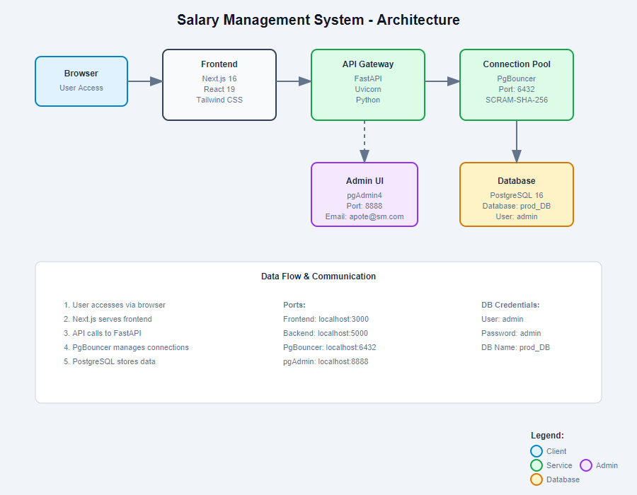

Approach:
- I have used Next.js as a frontend framework with shadcdn component library to integrate modern component design. I have created 4 pages login,signup,home and employee management along with authentication hooks to have authorized access to home and employee management page.
- My approach in using FastAPI is backend is because it is really high performing and lightweight async web server which is ideal case for fast response time apps.I have used alembic as migration engine and SQLAlchemy as database connector to connect to my Postgresql database.
- I have used Pgbouncer as connection pooler so that our database connections dosen’t get overwhelmed and slows down the database.
- Used PostgreSql as a realational database since it supports high performance queries and optimization techniques as well as storage of complex objects like JSON and JSONB.
- I coupled everything together with docker and docker-compose creating microservices architecture which takes away any dependency issues arising during production.
- I have followed TDD approach and created unit tests for backend api’s using pytest.
- I have used JWT token system for authentication and authorization.
- Have configured pgadmin for database administration purpose.

AI Agent:
Used opencode terminal AI agent installed using npm and confidured it to use MiniMax M2.5 model which has benchmarks quivalent to claude opus 4.6.

Notes: I have attached the working demo video file along with this repo.

